**Fractal Capstone Project - Retail Case study**

**Dhanuja Pani S D | Data Engineer | B2-Crossover Training | dhanuja.pani@fractal.ai**

**[Note:Please Ctrl+Click on the link to follow the link and view files]**

**Data prep task:**

**1.Create a Git folder and pull the data from Github**

I have created a folder ‘retail’ in local and have pulled the data from github ‘<https://github.com/akgeoinsys/retail.git>’ repository.The files were then extracted in the local

Commands used:

* mkdir retail
* cd retail
* git init
* git remote add dhanujagit ‘<https://github.com/akgeoinsys/retail.git>’
* git pull dhanujagit main
* ls
* unzip Retail-20210521T141851Z-001.zip
* cd Retail
* ls

**2.Load Data into MYSQL and HDFS:-**

I have used a shell script to automate the process of loading data to mysql.

mysqlfile.sh

* This script reads through all the files in the directory.
* And for each file it splits the file name and gets the table name
* Its appends the load command to the loading sql file
* The schema creation for mysql tables are done
* Later the data from each file is loaded to mysql table.

mysqlfile.sh-🡪Bash file

<https://github.com/DhanujaPani/retail_capstone_casestudy_files/blob/main/mysqlfile.sh>

retail_mysqlschema.sql🡪Contains the create queries for MYSQL tables

<https://github.com/DhanujaPani/retail_capstone_casestudy_files/blob/main/retail_mysql_schema.sql>

loadmysql.sql🡪Contains the load commands automated by the bash.

<https://github.com/DhanujaPani/retail_capstone_casestudy_files/blob/main/loadmysql.sql>

The counts are checked using counts.sql

<https://github.com/DhanujaPani/retail_capstone_casestudy_files/blob/main/counts.sql>

Thus, all files are successfully loaded.

**Load data into HDFS: -**

**I have created a bash script hdfsload.sh for moving all files from local to hdfs.**

[**https://github.com/DhanujaPani/retail_capstone_casestudy_files/blob/main/hdfsload.sh**](https://github.com/DhanujaPani/retail_capstone_casestudy_files/blob/main/hdfsload.sh)

**Files are loaded to HDFS**

**Hive task :**

**3. Create external table on top of existing HDFS project data as a Raw Table**

**I have created external hive tables on the file in hdfs by running the script.**

**Cmd:-**

hive -f hiveexternaltable.sql

[**https://github.com/DhanujaPani/retail_capstone_casestudy_files/blob/main/hiveexternaltable.sql**](https://github.com/DhanujaPani/retail_capstone_casestudy_files/blob/main/hiveexternaltable.sql)

**Create a optimized staging table to minimize the storage**

I have created hive tables and have stored them in different file formats.

Cmd: -

hive -f hivestagingcompress.sql

<https://github.com/DhanujaPani/retail_capstone_casestudy_files/blob/main/hivestagingcompress.sql>

File format Comparison: -

|  |  |
| --- | --- |
| File Format | Size |
| Original file | 7.0MB |
| ORC FILE | 79.5KB |
| Parquet FILE | 230.3KB |
| RCF File | 228.0KB |
| Parquet file | 252.7KB |

We could see that **ORC file** produces highest level of compression.

**Write 5 business queries with hive builtin functions?**

The queries are available in buisnessqueries.sql

<https://github.com/DhanujaPani/retail_capstone_casestudy_files/blob/main/buisnessqueries.sql>

**Query-1:**

**Finding which month of every particular year has the maximum no.of orders.**

**Built-in-functions used:** year(),month(),dense_rank()



**Query-2:**

**Finding the no. of customers from each nation**

**Built-in functions: -**count()

­

**Query-3: -**

**Generating Nation codes for each nation.**

**Built-in-function used: -**substring()



**Query-4: -**

**Rounding account balance:-**

**Built-in-function: -**round()



**Query-5: -**

**The company has decided to generate random numbers against each customer, pick a random number and gift all the customers with the random number a coupon.**

**Built-in function:-**rand()

**1.Creating a table with lucky_draw_numbers**



**2.selecting a lucky number from the list.**

**3.Setting the lucky number to be chosen from customers: -**

**4.Querying the table for the lucky person: -**



**And the lucky winner is:-**

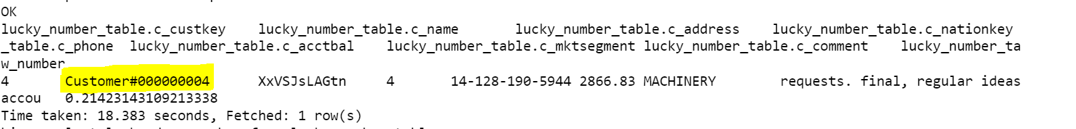

**4. Create a partition on multiple columns and bucket for optimized storage ?**

**Implement static, dynamic and bucket in a same table**

**State the reason for the usage and column selection**

**We are using the orders dataset.**

**1.Static Partition:-o_orderpriority[1-URGENT]**

**Reason:-**I have chosen this column to be static as we are going analyse the urgent orders so creating a static patition on o_orderpriority will help in retrieving the query results fast.

select distinct o_orderpriority from orders;

**Dynamic Partition: - o_orderstatus**

**Reason: -Under urgent orders we have 3 distinct status, so creating a partition on this will lead to 3 folders so if we have to analyse based on the status it would be easy.**

**select distinct o_orderstatus from orders;**

**Bucketing: - o_orderdate**

select count (distinct o_orderdate) from orders where o_orderpriority='1-URGENT';

**We have 1701 distinct date so creating bucket on o_orderdate would be optimal since we have more distinct column values**

**Based on the hash key of value % no.of buckets using o_orderdate might leave all the buckets filled .**

**Screenshots from warehouse: -**

**STATIC: -**

**DYNAMIC: -**

**Buckets: -**

**We could see that all the five buckets are of the similar size, which denotes bucketing ‘o_orderdate’ has used all the buckets almost evenly.**

**5. Do the data ingestion from RDB using sqoop apply all the functionality and incremental options**

**1.Create a mysql table: -**

**We have distinct c_custkey from 1 to 1500**

**Currently I have created a table with key <1000 to show incremental append in the below steps.**



**2.Create an external table in hive mapped to a hdfs location so each refresh of data to hdfs is reflected in the hive table.**



**3.Create a sqoop job to migrate data from mysql to the hdfs directory.**

**sqoop job --create custsqoopincappendjob -- import --connect jdbc:mysql://ip-10-1-1-204.ap-south-1.compute.internal:3306/unextjun12 --driver 'com.mysql.jdbc.Driver' -username unextjun12 -password BdhData123 -table customer_sqoop --target-dir /user/unextjun12/retail.db.db/customer_hive_sqoop --incremental append --check-column c_custkey -m 1**

**4.Check list of jobs;**

sqoop job --list

**Job is created.**

**5.Execute the job**

sqoop job --exec custsqoopincappendjob

**Upper bound value is set to 999.**

**6.Lets try inserting new records into mysql table, the records with c_custkey greater than 1000.**



**7.Execute the sqoop job once again to refresh the data.**

sqoop job --exec custsqoopincappendjob

**Lowerbound=999,Upperbound=1500**

**HDFS SCREENSHOT:**

**HIVE :-**

**The data is loaded from mysql to hive through sqoop.**

**Spark Task :**

[**https://github.com/DhanujaPani/retail_capstone_casestudy_files/blob/main/dhanujasparktask.py**](https://github.com/DhanujaPani/retail_capstone_casestudy_files/blob/main/dhanujasparktask.py)

**Creating a spark session**

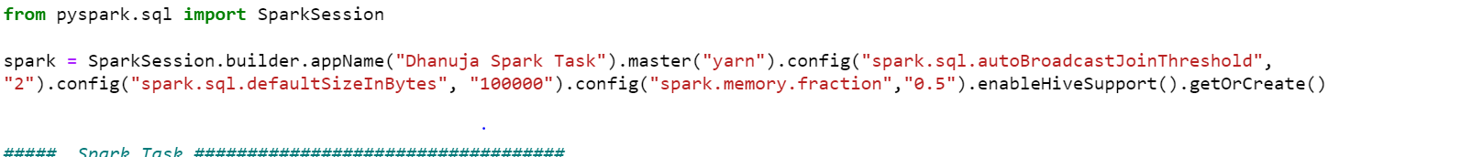

**Importing :**

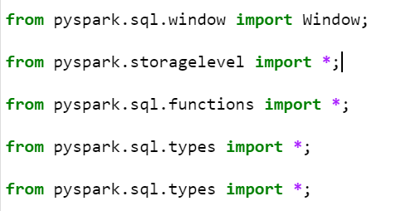

**6.Create a dataframe as source from csv file and apply cleansing , scrubbing , filter the bad records , change the date format , replace nulls**

**7. Connecting with mysql table and create dataframe apply upper bound and lower bound for partition**

**create hive table and apply partition and bucketing**

**8. Apply transformations using withcoulmn /withcoulmnRenamed**

**dropna/fillna/replace**

**cast/alias/aggregation**

**filter/sort/select**

**Ship mode with most no.of orders:-**

**Joins with join optimization techniques:**

**Handling different file formats with compression codecs**

**BZIP2:**

**GZIP:-**

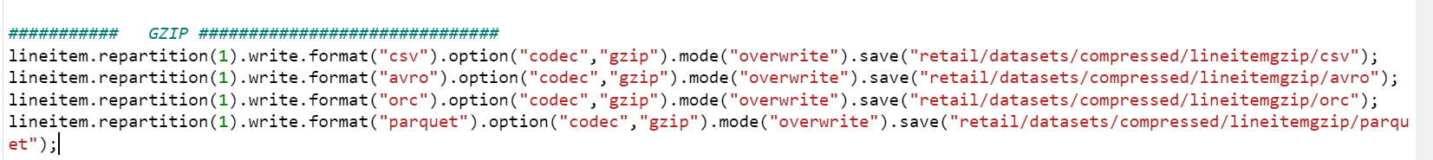

**SNAPPY:-**

**9. Implement Delta table and perform Transactional property**

**Merge schema and time travel**

**Even upon rewriting the delta with new data we are able to see the older version of data**

**Version 0:-**

**Version-1:**

**10. Memory management and optimization**

**Implement persist /cache with effective storage level**

MEMORY ONLY



**MEMORY_ONLY_2**



**MEMORY_AND_DISK**



**11. Write the .py file for entire spark task and use cache/persist with storage level and deploy that in cluster mode . submit the spark job in YARN cluster**

**Have wrtiten all the spark queries in a .py file 🡪 dhanujasparktask.py**

**I have ran the above file using the below spark submit**



At the same time 15:14 – history server screenshot

**All the queries are completed:-**

**BUISNESS QUERY:-**

[**https://github.com/DhanujaPani/retail_capstone_casestudy_files/blob/main/buisnessquery.py**](https://github.com/DhanujaPani/retail_capstone_casestudy_files/blob/main/buisnessquery.py)

The Pricing Summary Report Query provides a summary pricing report for all line items shipped as of a given date. The date is within 60-120 days of the greatest ship date contained in the database.The query lists totals for extended price, discounted extended price, discounted extended price plus tax, average quantity, average extended price, and average discount. These aggregates are grouped by RETURNFLAG and LINESTATUS, and listed in ascending order of RETURNFLAG and LINESTATUS. A count of the number of line items in each group is included

I have created a file buisnessquery.py with all the queries.

Creating dataframe:-

**Creating the required column:-**

L_DISCOUNTAMT = >L_DISCOUNT * L_EXTENDEDPRICE

L_TAXAMT = >L_TAX * L_EXTENDEDPRICE

L_DISCOUNT_EXTENDED_PRICE 0 => L_EXTENDEDPRICE * L_DISCOUNTAMT

L_DISCOUNT_EXTENDEDPRICE_PLUS_ TAX => L_DISCOUNT_EXTENDED_PRICE * L_TAXAMT

L_MAXSHIPDATE => MAX(L_SHIPDATE)



**Filtering the records for 120 days**



**Creating calculated columns:-**

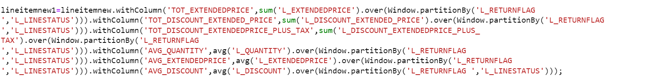

**Joining columns df with count df**

**Creating a report with all columns casted to bigint to avoid exponential numbers.**

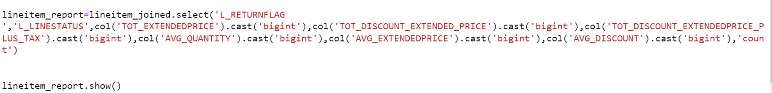

**Count validation with mysql**

**12. Kafka task; Spark Integration**

**Create a kafka producer to read the file and topics with replication , partitions**

**Integrate with spark streaming :**

**consume it in spark streams and join with batch data**

**Apply watermark and user defined function (UDF)**

**I have read the files using procer and have consumed the data throgh consumer under the below topics.**

* **order_unextjun12**
* **lineitem_unextjun12**

**kafka-topics --create --zookeeper 10.1.1.204 --replication-factor 1 --partitions 1 --topic order_unextjun12**

**kafka-topics --create --zookeeper 10.1.1.204 --replication-factor 1 --partitions 1 --topic lineitem_unextjun12**

**I have attached the HTML copy of jupyter notebook for producer and consumer codes.PFA.**

[**https://github.com/DhanujaPani/retail_capstone_casestudy_files/blob/main/Kafka%20Producer%20Lineitem.html**](https://github.com/DhanujaPani/retail_capstone_casestudy_files/blob/main/Kafka%20Producer%20Lineitem.html)

[**https://github.com/DhanujaPani/retail_capstone_casestudy_files/blob/main/Kafka%20Consumer%20Lineitem.html**](https://github.com/DhanujaPani/retail_capstone_casestudy_files/blob/main/Kafka%20Consumer%20Lineitem.html)

[**https://github.com/DhanujaPani/retail_capstone_casestudy_files/blob/main/Kafka%20Producer%20Orders.html**](https://github.com/DhanujaPani/retail_capstone_casestudy_files/blob/main/Kafka%20Producer%20Orders.html)

[**https://github.com/DhanujaPani/retail_capstone_casestudy_files/blob/main/Kafka%20Consumer%20Orders.html**](https://github.com/DhanujaPani/retail_capstone_casestudy_files/blob/main/Kafka%20Consumer%20Orders.html)

**Code used to remove double quotes from each line written by consumer:-**

**This is the bash script used to load data from the file written by consumer to hive tables:**

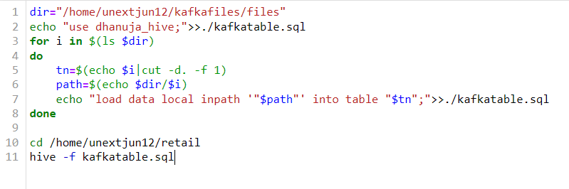

**Data loaded to hive:-**

**13. Implement Jenkins CI/CD**

**1.Created a new pipeline retail_casestudy_tar in jenkins**

**Script for pipeline :-**

**2.Build now**

**3.Job#1 got triggered and the build was created successfully**

**4.Console Output:-**

**Validating in the workspace:-**

**/var/lib/jenkins/workspace/retail_capstone_tar**

**Terminal:-**

**Changed diectory to workspace**

**Tar file myfile.tar is created in the workspace.**